Task on AWS Lambda
AWS Lambda is a serverless compute service from Amazon Web Services that lets you run code without provisioning or managing servers.

🚀 What AWS Lambda Does
Instead of setting up servers, you simply:
- Write your code (called a function)
- Upload it to Lambda
- Trigger it via events
Lambda automatically:
- Scales up/down based on demand
- Runs your code when needed
- Charges you only for execution time

⚙️ How It Works
- You create a Lambda function (Node.js, Python, Java, etc.)
- You define a trigger (event source)
- Lambda executes your function when the event occurs

🔔 Common Event Triggers
- HTTP requests via API Gateway
- File uploads to S3
- Database changes (DynamoDB streams)
- Scheduled events (cron jobs)
- Messages from queues (SQS)

💡 Example Use Cases
- Building REST APIs
- Processing uploaded files
- Running backend logic for mobile/web apps
- Automating tasks (e.g., sending emails, resizing images)
- Real-time data processing

💰 Pricing Model
You pay for:
- Number of requests
- Duration your code runs (in milliseconds)
- Memory allocated
There is also a free tier, which is enough for small apps.

👍 Advantages
- No server management
- Automatic scaling
- Pay-as-you-go
- High availability
👎 Limitations
- Cold start latency (small delay when idle)
- Execution time limit (up to 15 minutes)
- Stateless (no persistent memory between runs)

Create a function
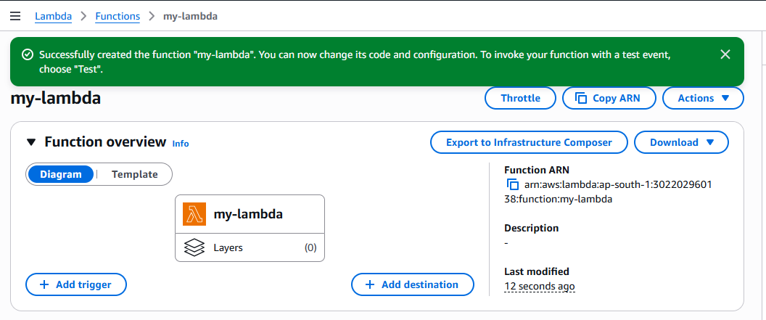

Common Triggers You Can Add
Click Add Trigger and choose:
- S3
- API Gateway
- CloudWatch
- Event Bridge
- SQS
Example:
- Upload file to S3 → Lambda automatically runs

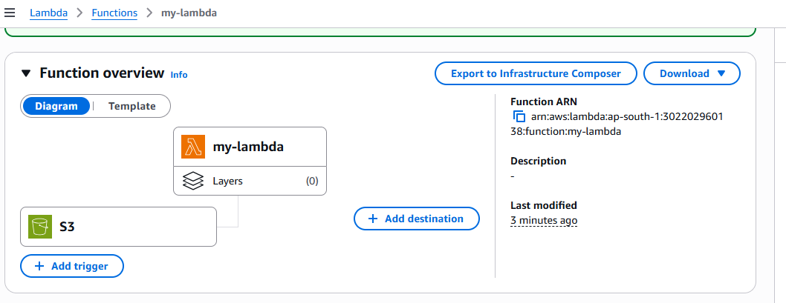

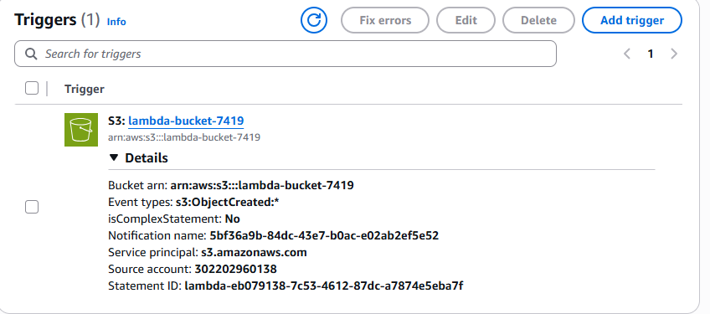

Create an event and test
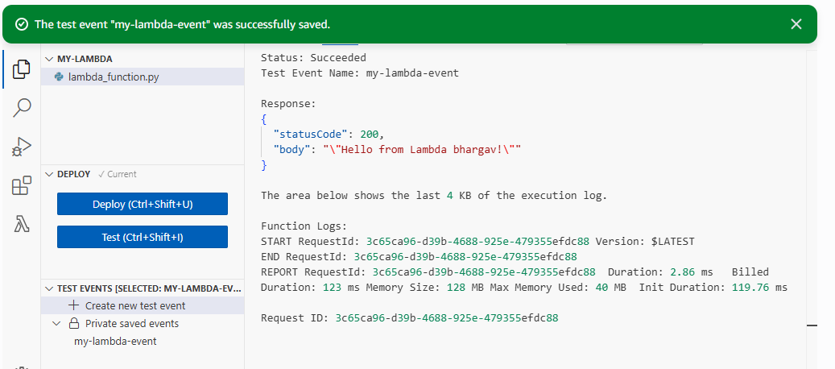
Check in the event notification in S3
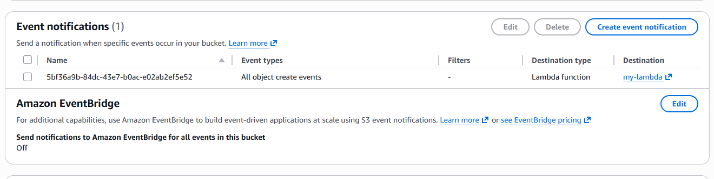
We can check in the cloud watch log management
